Exterior Angles

For each shape below, measure and mark on the exterior angles. Then add the answers together for each shape and complete the sentence alongside.
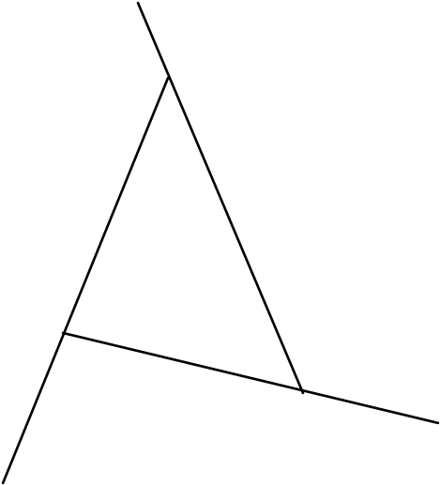

The three exterior angles in the triangle add up to ……….

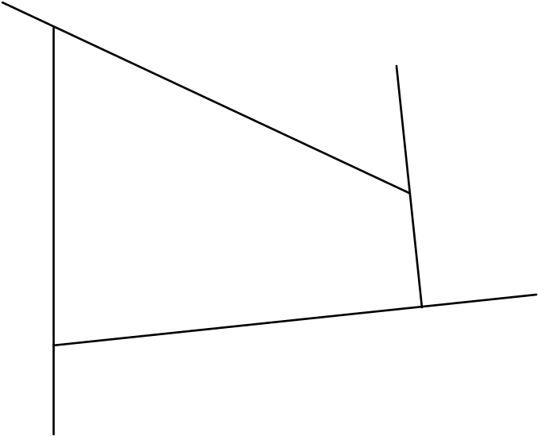

The four exterior angles in the quadrilateral add up to ……….



The five exterior angles in the pentagon add up to ……….

